Event No | Time | Management (organization) | Officers(human) | Crew(Human) | Vessel(Technical) | Contributory factors
E1 | 3 days delay  0500 on 15 December to 2300 on 18 December | Burke Agencies  Pressure to enter port for minimizing demurrage |  |  |  | Due to delay of unloading in the earlier ships
E2 | 1415 |  |  | Neither the bridge team nor the pilot received the weather forecast by Clyde coastguard |  | Did not changed the channel to VHF
E3 | 14.30 on 18 December |  |  | Pilot compromised without day light |  | Pilot did not want to navigate the ship up river on Wednesday 02.30 to 07.00  Fog forecasted early morning
E4 |  |  |  | Pilot considered three tugs are sufficient |  | Did not follow the pilotage directions and guidelines
E5 |  |  | Harbourmaster Could not able to provide second pilot |  |  | Due to unavailability
E6 | 1600 |  |  | Pilot not received sufficient weather report |  | He only received wind and tide information.  He has not received any due information
E7 |  |  | Deputy Harbourmaster has not recived information about fog |  |  | Erskine bridge operator does not have able to predict weather forecast
E8 | 1717 |  |  | Pilot reported his position wrongly |  | Pilot reported as he was at Dunglass instead of Esso Bowling Jetty
E9 | 1719 |  |  | Pilot come to know the fog |  | Overheard the report made by Yoker Swan to Estuary Control
E10 | 1750 |  | Svitzer Mallaig’s skipper reported thick fog ahead
E11 | 1753 |  |  | Pilot not able to see Svitzer Mallaig deck light |  | Due to dense fog
E12 |  |  |  |  | Red Jasmine not able to turn starboard side in time | Rate of turn was not sufficient
E13 |  |  |  | Pilot instructed to Flying Phantom to take the vessel bow to starboard |  | In order to increase rate of turn
E14 | 1755 |  |  | Pilot instructed stop pulling and ordered to hard port |  | Due to the earlier command it turns sufficiently.  To study the ship ahead
E15 | 1756 |  |  | Dead slow ahead was order to Red Jasmine helms man |  | Flying Phantom and Red Jasmine entered in fog
E16 | 1758 |  |  | Pilot ordered Flying Phantom skipper to take the Red Jasmine head to starboard |  | Pilot realized that he could no more able to control with Red Jasmine rudder
E17 | 17:58:31 |  |  | Pilot instructed Flying Phantom skipper to bow needed to move further starboard |  | Red Jasmine was not turning sufficiently and heading towards grounding
E18 | 17:59:02 |  |  | Pilot instructed to Flying Phantom to ease off
E19 | 17:59:19 |  |  | Pilot instructed crew of Flying Phantom to let go their tow line |  | Mate of Flying Phantom stated grounded
E20 | 18:00:35 |  |  | Flying Phantom grounded |  | Towing line is not released in time.  View of Towing winch is not visible – camera system has not operated.
E21 |  |  |  | Only the Mate clambered out of the wheel house |  | Expected the rest of the crew will follow him
E22 |  |  |  | Community warden raised the alarm |  | Heard the call of mate
E23 |  |  |  | Those on shore not able to see the mate |  | Due to thick fog

Technical:
Emergency release system not operated quickly
Tug is not designed for girting
Fog detectors not available
Engine room doors sill immersed at 30deg heel
Emergency release system is not designed for girting
Tugs bride equipment – well positioned to assist them in blind operations

Crew / Operator / Human error:
Routine observation prior to tow- ineffective
Port side Engine room door opened. This is reduced the range of stability
Mate was expecting others will follow him
Lack of situation awareness

Organization:
Svitzer Marine Ltd:
No operation limits in tug operations -restricted visibility
No procedures - restricted visibility
Clyde Port:
Risk assessment poor
Inadequate controls in thick fog
Quality management systems –flawed
Fog detection system not purchased
UK ports:
not improved controls due to earlier accidents
Classification / Statutory bodies:
Lack of standards for towing winch emergency release system
Training- blind pilotage operations

Visibility : refer page 165
Fault tree : Refer 195
FSA : Formal safety assessment : refer 283
Accident Analysis:

Task complexity
Lack of Communication
Pilot
Individual
Situation awareness
Traning
Towing winch
Hardware
Vessel
Crew
Performance of crew and piolt
Classification
Towing winch
Vessel
Task complexity
Lack of Communication
Pilot
Individual
Ownership of Tug
Individual
Weather forecast info
Hardware
Situation awareness
Ownership of port
Port facilities

Operation
Pilot
Aid to Navigation
Performance of crew and piolt
Lack of Communication
Ownership of Caro / Vessel

Task complexity
Environment
Girting
Grounding
Crew
Traning
Traffic
Evaculation
Fog
Nature

Ownership of Vessel
Vessel
Lack of Communication
Towing winch
Ownership of Caro
Task complexity
Aid to Navigation
Hardware

Situation awareness
Performance of crew and piolt
Classification
Grounding
Tug operators
Traning
Evaculation
Girting
Port facilities
Operation

Pilot behaviour
Weather forecast info
Environment
UK Port Authority
Individual
Crew behaviour
Ownership of port
Traffic
Fog
Nature

Performance shaping factors : The following parameters are influencing on the performance of crew in navigation of ship in the channel. The reliability of the crew/ pilot is depends on the PSF. Those are listed below:
Available time
Experience and Training in fog
Stress and Stressors
Task complexity
Situation awareness
Ergonomics (Human machine interaction)
Environmental factors
Procedures and Guidelines
Insufficient information about vessel position in fog
Insufficient information about fog
Changing the ship (Tug crew)

Weather & Seastate
Fair ways

Water Way
Pilotage pattern

Motion

Accident

Severity

Step Diagram: refer 372
What is a Scenario?
The scenario could be based on known accidents or incidents. The scenarios should be selected on the basis of the following criteria:
• The scenarios should be realistic. It should cover all the parties involved in the accident.
• It should have a potential of major losses.

STEP (Sequentially Timed Events Plotting diagram) diagram has a proven method for describing the accidental scenario. A STEP diagram illustrates the actors and events in a time-line diagram. STEP diagram for Flying Phantom has included below. This methodology can be used for STEP improved communication and understanding situation. The Scenario Analysis addresses alternative sequences, i.e. “what could have happened if “..

ysr_phy@rediffmail.com
Flow charts of events: refer 375

http://www.sciencedirect.com/science?_ob=ArticleListURL&_method=list&_ArticleListID=927853783&_sort=d&view=c&_acct=C000030078&_version=1&_urlVersion=0&_userid=586462&md5=59256ec3a8900d55d37219c21bb930c5

Fishbone diagram:
- Also known as cause-effect-diagrams
- Developed by Ishikawa in the early 1950s (Kawasaki Company)
- The method consists of defining an occurence of a typically undesirable event or problem (fish head)
- Identifying contributing factors “causes” or fish bones

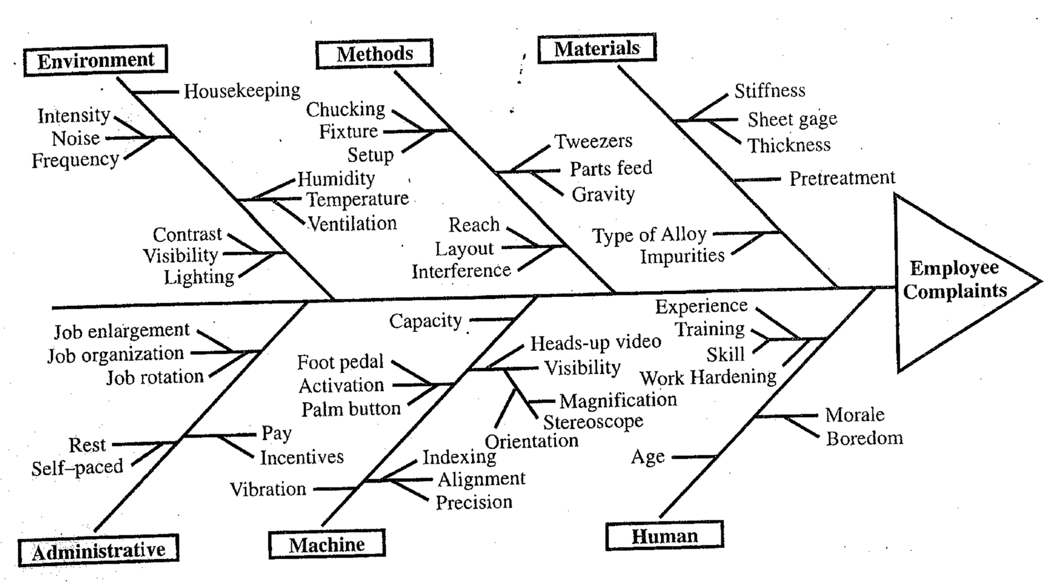
Investigation technique:
Fault Tree Analysis (FTA):
Fault Tree Analysis (FTA) is a logic diagram showing all the potential causes of an accident or other undesired event. FTA involves these steps:
1. Define the undesired event to study.
2. Obtain an understanding of the system.
3. Construct the fault tree.
4. Evaluate the fault tree.
5. Control the hazards identified.
This information determines the most probable sequence of events leading to the accident.
Another investigation technique would be a Job Safety Analysis (JSA). A JSA is based on the following steps:
1. Select the job to be analyzed.
2. Separate the job into its basic steps.
3. Identify the hazards associated with each step.
4. Control each hazard.

