Cloning of a RLK gene using

Gateway technology

Figure 1. Illustration of a PCR-reaction.

Introduction:
The Gateway Technology is a rapid and efficient cloning method, moving DNA sequences from an entry vector to a destination vector while maintaining the reading frame around. The method eliminates the need for restriction enzyme, gel purification and ligation by taking advantages of site specific recombination. Figure 2 illustrates how an attP-gene sequence from a phage λ is combined with an attB-gene sequence from the bacteria E.coli, and by this method eliminates the need for a restriction enzyme (1, 2)
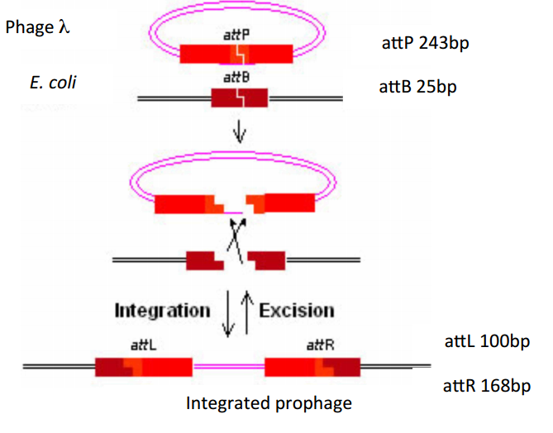
Figure 2. A combination of a phage λ and a E.Coli-gene
The RLK-gene (receptor-like kinases) is present in the Arabidopsis plant genome. The RLK-gene was the gene of interest in the laboratory test. RLK’s are transmembrane proteins with striking resemblance in domain organization to the animal receptor tyrosine kinase which communicate signals within the cell and regulate cellular activity. There are over 600 RLK-genes in the Arabidopsis genome and the function for all of them is not known, but as an overview they control development, disease resistance, hormone perception and self-incompatibility. A large group of the RLK’s is called LRR (leucine-rich repeats). They often participate in protein-protein interactions (3). Further the LRR RLK (AT1G74360) gene function in protein serine/threonine kinase activity, protein kinase activity, ATP binding and the gene is expressed in nine growth stages in the Arabidopsis (4).
The BP-Reaction combines the attB-PCR-product with the donor vector. The BP-Clonase enzyme mix replace the “by product gene” with the attB-PCR-product gene so the results is an entry clone and a by-product as illustrated in figure 3.
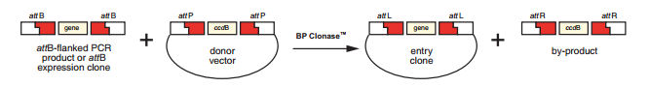
Figure 3. BP-Reaction

Material and methods:
Gene of interest (LRR RLK AT1G74360) was amplified by PCR for cloning (appendix 1-2). Then the gel electrophoresis was performed so that the PCR product could be extracted from the gel afterwards (appendix 3).

Extraction of PCR product from the gel:
The gel was loaded and run after the protocol. A micro centrifuge tube was used for the DNA fragment from the gel. A membrane binding solution was added to the agarose gel slice (10µl/10mg agarose) and the mixture was mixed then incubated at 50-65ᵒC for 10 minutes.

DNA-Purification:
The dissolved gel mixture was transferred to a SV minicolumn and incubated in room temperature for 1 minute. The column was then centrifuged at 14000 rpm for 1 minute then the liquid in the collection tube was discarded. The column was then washed with membrane wash solution (700µl, previously diluted with 95% ethanol) and centrifuged for 1 minute. The liquid was discarded and another wash (500µl) were performed before a third round of centrifuge for 5 minutes. The SV minicolumn was transferred to a clean tube, nuclease-free water was applied (50µl) without touching the membrane. The mixture was incubated at room temperature for 1 minute and centrifuged for 1 minute. The product was eluted DNA.
From there a BP-reaction was performed, and a L.B medium was prepared for bacterial transformation. The bacteria were plated out.
The next day we checked the plates for BP-reaction and did a PCR control for positive transformant colonies. The positive colonies went through a gel electrophoresis before a liquid culture of single positive colonies was started.
Then we did an extraction of plasmids from the liquid culture and checked the quality and quantity of the plasmids by Nanodrop. A LR reaction was started and after that the bacteria was plated out.
The plates were checked for LR reaction and a PCR control for positive colonies was performed. The last gel electrophoresis was performed before a last downstream processing of the obtained gene construct.

Literature list:
- http://tools.invitrogen.com/content/sfs/manuals/gatewayman.pdf
- Powerpoint fra itslearning
- http://shiulab.plantbiology.msu.edu/wiki/images/pdf/STKE01_rlk_review.pdf (p.1)
- http://arabidopsis.org/servlets/TairObject?id=28523&type=locus

Appendix:

PCR-reaction for amplifying of target genes:
PCR Buffer (10X) 5µl
dNTPs (10mM) 4µl
Primer F 1µl
Primer R 1µl
DNA Temp 1µl
TAKARA Ex-Taq DNA Pol 1µl
MQ water 37µl

Total volume: 50µl

Start with water and mix everything together with the water.

PCR Profile:
Denaturing 94°C 1 min
Annealing 50°C 30 sec 5 cycles
Extension 68°C 1 min/kb

Denaturing 94°C 1 min
Annealing 55°C 30 sec 30 cycles
Extension 68°C 1 min/kb

Agarose gel electrophoresis:
TAE Buffer (1X) 110 mL
Agarose powder 0,9gr (1%)

Add agarose to the buffer and boil in the microwave for 3 min. Cool down to 55-60 °C and add 5,5µl (20,000X) of Gel Red before pouring it into a gel tray for solidification.

Add 5µl of loading dye (10X) to the PCR-product and load it into separate wells in the gel.

BP-Reaction:
Recovered PCR product 2µl
Pdonor/Zeo 0.5µl
BP-Clonase 0.5µl

LR-Reaction:
BP-plasmids 1.5µl
Destination Vector 0.5µl
LR-Clonase 0.5µl

PCR for destination vector control:
PCR Buffer (10X) 9µl
dNTPs (10mM) 9µl
Primer F 4µl
Primer R 1µl
DNA Temp 1µl
TAKARA Ex-Taq DNA Pol 1µl
MQ water 37µl

Total volume: 50µl

