Fakultet for Ingeniørvitenskap og Teknologi, NTNU
Subsea compression Gullfaks Sør satellite field
EiT - Gullfaks village 2013

Group 1
Teeub Amirbayov, Juan Carlos Glora Lopez, Dicky Harishidayat, Ailo Aasen, Ole Christian Auran and Malin Kristina Salmi Stavrum
5/2/2013

Abstract
Statoil has decided to implement subsea compression in means of extending the production period of the gas producing satellite field, gullfaks sør. The objective of this project was to review ways to increase the gas recovery from the gullfaks sør field, trying to model it with simpler tools, and hopefully highlighting issues Statoil may have overlooked. We considered two subsea templates (L- and M-template), both during pre-compression and after installation.

The objective is basically to maximize the profits (NPV).

Preface
This report is written as part of TPG 4851 Experts in Team, Gullfaks Village spring 2013, in cooperation with the Statoil Gullfaks license in Bergen. The goal of this village has been to to review new ways to increase the gas recovery from the satellite field, Gullfaks Sør by installing new subsea equipment or other means.
We would like to thank the village supervisors Jon Kleppe ,Jan Ivar Jensen, Michael Golan, Milan.., , for helpful guidance throughout the project.

We would also like to thank the project supervisors….. in Statoil

Trondheim, April 2013

Teeub Amirbayov, | Ailo Aasen
Juan Carlos Glora Lopez | Ole Christian Auran
Dicky Harishidayat | Malin Kristina Salmi Stavrum

Table of Contents
Abstract 1
Preface 2
1. Introduction 4
2. Part A 6
2.1 Method of execution 6
2.2 Result and discussion 7
2.1.1 Compressor map 9
3. Part B 10

List of table and list of figures. Optional.

Introduction
The Gullfaks field started producing oil and gas December 1986. Since the production-start, Statoil has used new technologies to achieve higher recoveries for oil and gas from the field.
The Gullfaks field lies in block 34/10 of the northern part of the North Sea. The main field has three production platforms (A, B and C) with concrete substructure. The gullfaks field is illustrated in figure 1.
Gullfaks A-plattformen startet produksjonen 22. desember 1986, Gullfaks B den 29. februar 1988 og Gullfaks C den 4. november 1989.
Oljen som produseres, lastes i bøyer på feltet, mens gassen blir transportert i rørledning for behandling på gassanlegget på Kårstø i Rogaland. Derfra går gassen til eksport.
Gullfaks A benyttes også til lagring og utskiping av stabil råolje fra feltene Vigdis og Visund.
Satellittfeltene Gullfaks Sør, Rimfaks, Skinfaks og Gullveig er bygd ut med undervannsbrønner som blir fjernoperert fra Gullfaks A- og C-plattformene.
Utvinningsgraden på Gullfaks er 59 prosent, men målet er å øke denne til 62 prosent.
Blant tiltakene for økt utvinning inngår horisontale og langtrekkende brønner, ny teknologi innen komplettering og sandkontroll og alternerende vann- og gassinjeksjon. Gullfaks ble tildelt i 1978 til de tre norske selskapene Statoil, Norsk Hydro og Saga Petroleum, med Statoil som operatør.

Gullfaks Sør is a satellite field developed with subsea wells which are remotely operated from Gullfaks A and C platforms.
The M and L field is located 14 kilometers from the platform.
Gullfaks sør also includes the separate structures Rimfaks og Gullveig.
The gas from the gullfaks area is sent to korsø, Stavanger.The oil and condesate is stabilized is stored asn loaded from the A- and C platforms.
Gullfaks Sør ligger i blokkene 34/10 og 33/12 i den nordlige delen av Nordsjøen. Havdybden er fra 130 til 220 meter.
Blokkene ble tildelt i henholdsvis 1978/1995 og 1973 (fradelt 1998).
Feltet er en satellitt til Gullfaks-feltet og er bygget ut med installasjoner på havbunnen. Utbyggingsfase I ble godkjent i mars 1996, med produksjonsstart i oktober 1998. Fase II ble godkjent i juni 1998, med produksjonsstart i oktober 2001.
Fase I omfatter produksjon av olje og kondensat, med reinjisering av assosiert gass. De åtte undervannsinstallasjonene i denne fasen er tilknyttet Gullfaks A-plattformen for prosessering, lagring og lasting.
Fase II omfatter produksjon og eksport av gass og assosierte væskemengder fra undervannsinstallasjoner knyttet opp mot Gullfaks A- og C-plattformene.
Kilde: Statoil, http://www.statoil.com/no/OurOperations/ExplorationProd/ncs/Gullfaks/Pages/GullfaksSouth.aspx, 10/4-2013

The gas from the Gullfaks sør field contains condensate which makes the gas more valuable. The Gullfaks Sør satellite field can produce up to .. condensate per year, representing $...
To achieve a higher gas recovery factor from the Gullfaks Sør field, a multi-phase subsea compressor is planned to be installed and start running in year 2015.
The key concept for the Gullfaks village is to increase the oil and gas recovery. The project has been divided in to two parts, A and B, where part A Part A is a
In Part B further flow optimization of natural plateau using the chocke, flow assurance, hydrade formation, lower pressure modification and economic analysis is studied.

The purpose of part A is to obtain the simplest possible model of the. The main assumptions we made were
- A dry gas model
- We consider only horizontal flow in a pipe, neglecting vertical distance and the consequent pressure loss

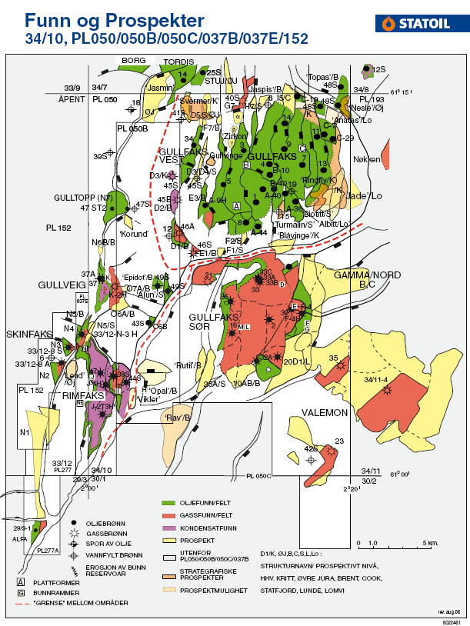
Figure 1. Map of gullfaks area [Source, PowerPoint Margrete]. The subsea satellite gullfaks sør field is shown in the blue circle, to the south of the gullfaks main field.

Part A
In part A the dry gas was compared to the dry gas scenario to compare the differences.

2.1 Method of execution
After being presented the relevant data (e.g. production days per year, reservoir temperature and various physical flow parameters) and a simplified set of governing equations, we made the excel sheet.
- The first period is the natural plateau, with constant total flowrate of 10^6 Sm³/day. In this period the reservoir pressure is high enough that you don’t need compression. We tried to prolong this period by adjusting chokes.
- After the reservoir pressure has dropped to the point where we can’t get 10^6 Sm^3/day, the compressor is installed, allowing us to still produce with 10^6 Sm³/day, prolonging the plateau for two more years.
- The differential pressure of the compressor is limited to 32 bara, which means that after this we have to decrease the flowrate to avoid overloading the compressor. We continue production until the flowrate reaches 5 Sm³/day.
We were also presented a compressor chart made in excel, where we basically could check if the compressor will be able to perform as we want it to.

2.2 Result and discussion

Flow rates q, for template L-east and M-west, were manipulated manually in exel to extend the natutal platau with a total flowrate of 10 millions sm³ per day. By placing the choke on the seabed, the natural plateau was detemined to end in June 2015. At the end of the natural platau, the comressor was installed to further extend the plateau of 10 million sm³ per day, until ∆P over the compressor reached the maximum capacity of 32 bars. The flows from each well were optimized by using solver in exel. Figure 2 illustrates the flowrate for template L and M during the production period of 2008 to 2024. Figure 3 and 4 illustrates the pressures for the well head, well flow, revervoar, seperator, towhead and template during the production period for template L and M respectively.

Figure 2. Flow rate for template L and M vs. Year.

Figure 3. Well head-, well flow-, reservoir-, separator-, towhead- and template pressure for template-L versus time.

Figure 4. Well head-, well flow-, reservoir-, separator-, towhead- and template pressure for template M versus time.
The total decreasing production flow rate is illustrated in figure 4.

Figur 5. The total flowrate for template M and L in between year 2008 - 2024.
The recovery factor for template M and L is illustrated in figure 5.

Figure 6. The recovery factor for template L and M
The recovery factor for field L and M were determined to be 0.61 and 0.71 respectively. In figure 6, two jumps in the graph can be seen in the middle of 2015 and in 2018. The first jump is due to the compressor starting. The total production rate of 10 million sm3 will then be held constant till 2018. From 2018 the total production rate will start to decrease from 10 million sm3 till it has reached its economical limit of 5 million sm3 per year/day.

Compressor map
The compressor map….
Constraints
There are several constraints related to the compressor:
- Compressor speed : N= (2000-4500) rpm. This is a recommendation from Framo Engineering.
- The discharge temperature: T_{d} < 110°C. This limitation is related to buckling of the pipe.
- Power consumption of each compressor is set to a maximum of 5MW.
- Maximum pressure increase over the compressor(ΔP) is 32 bar.
Results from the compressor map
Results from the compressor map is based on the flowrates and pressures from the excelfile. One compressor map was made for each year. The compressors were set in parallell. This figure shows the production from 2016, where the red dot indicates the operating point. The black lines is the test conditions(design) of the compressor and the red lines lines is the actual conditions. From the figure it is clear that the actual conditions deviates a lot from the test conditions. This means that the compressor is not functioning in a proper way.

Figure 7. Compressor map of production year 2016. Pressure ratio plotted against the flowrate.
Rest of the results show that the operating point of the compressor is located outside the map.

Part B

