‘Vermiculite no 5’ grinded. Size of particles similar to those of Na-Fh.
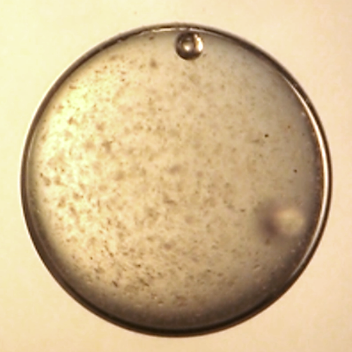 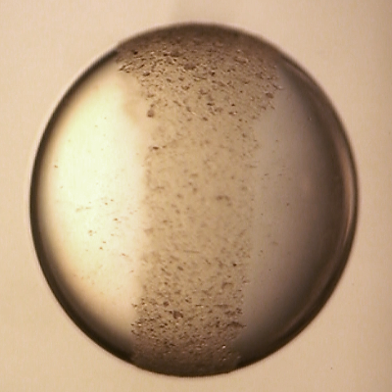 FRONT VIEW
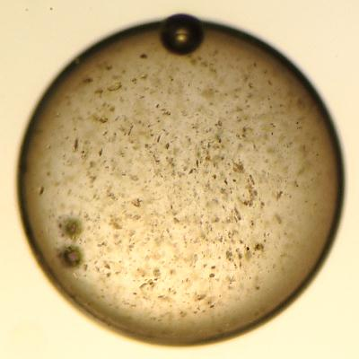 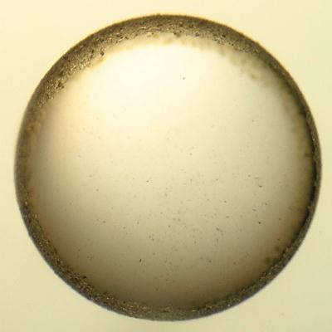 SIDE VIEW (along E-field lines)
0 min 5 min (at ~200 V/mm)

BEHAVES SIMILARLY TO NA-FH or Lp
‘Vermiculite no 5’ chopped mixed with grinded.
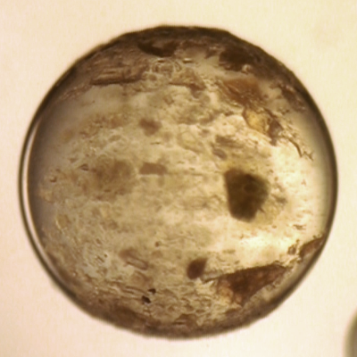 FRONT VIEW
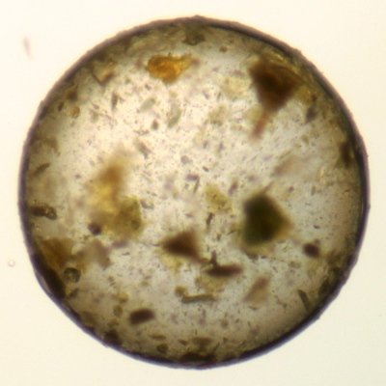 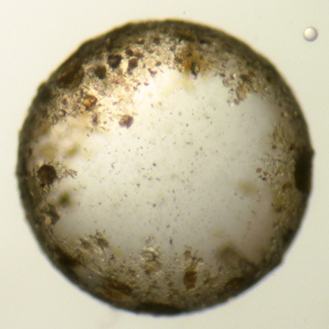 SIDE VIEW (along E-field lines)
0 min 5 min (at ~200 V/mm)
BEHAVES SIMILARLY TO those chopped Na-FH that you though was VERMICULITE

