Chapter 1 – Business Strategy Context for Operations Strategy
Strategy defined as “a plan of action designed to achieve a long-term or overall aim.” Strategy is the way a company moves from the current state to a desired future state. Aim to gain a competitive advantage over competitors. (lecture slides)
Two points of view have emerged as most prominent on strategy.

Competitive strategy: The positioning view
One should seek to become a dominant player in a good industry, according to Porter. Industries comprise suppliers, buyers, potential new entrants, incumbent competitors and possible substitutes Five forces model (p.6). Ideal industry from this model: few competitors, thousands of competing suppliers that could be pitted against one another to reduce prices and improve quality and service, millions of eager customers, no possible substitutes and high barriers to entry for new participants. Limited options for how a firm might position itself to gain such a dominant position:
- Cost leadership: low-cost provider
- Differentiation: delivering a set of unique products/services
- Focus: serve a narrow segment of the market
Furthermore, firms can choose to distinguish by three orientations: variety-based (tailor activities to deliver particular products, features or services across a range of customer groups, thus meeting a subset of customer needs. E.g. no frills service of an airline.), needs-based (tailor activities to meet particular needs of a distinct customer group or purchasing occasion. E.g. IKEA serving young first-time homebuyers), access-based (tailor activities to reach differently accessible customers with similar needs.E.g. Carmike Cinemas operates theaters in cities and towns with populations under 200,000).
Key in competitive strategy view: identify a desired position in the industry and then structure the activities and develop the capabilities of the firm to match or fit the requirements of that position.
Popular approach to strategy development that arose from this view: SWOT-analysis (p.7)

Critics
- Narrowly focused on industry and product economics
- Allows too few options for positioning a firm
- Relies too much on analytical tools for strategy identification and assessment
- Does not acknowledge the need for learning and adaption over time

Capabilities Development and leveraging: The resource-based view
80s: rising power and global competitiveness of Japanese industry. Their competitive advantage could not be explained simply by a positioning argument. Partly a result of the desire to better understand the Japanese threat and Japan’s approach to business and operations strategy development, the RBV gained attention and credibility.
RBV argue that competitive advantage is derived from the firm’s development of its resources and capabilities. Firms occupy different market positions because they possess unique bundles of resources and capabilities that are valuable (allow the firm to improve its market position relative to competitors), rare (in relative short supply) and inimitable (difficult and costly to imitate or replicate). Resources and capabilities are difficult to replicate when they are protected by intellectual property laws or are costly to learn and develop.
Resource: An asset or input to production (tangible/intangible) that an organization owns, controls, or has access to on a semi-permanent basis (example of definition from p.8)
Capabilities are the processes, activities, or functions performed within a system and reflect the ability of an organization to perform a coordinated set of tasks, utilizing organizational resources, for the purpose of achieving a particular end result. Competencies refer to the fundamental knowledge –know-how, experience, innovation, and unique information – owned by the firm, while capabilities reflect an organization’s ability to use its competencies.
Capabilities are developed through a firm’s experience, focus and effort over time. As firms learn, they tune their capabilities, giving them a competitive advantage that is difficult to replicate without going through the same long-term learning process. In the book: four dimensions along which capabilities might be framed:
Process-based capabilities: anchored in the activities a firm undertakes to transform material or information into products and/or services, focus often on achievement of cost and quality outcomes. Ex: a technology that none of the competitors have been able to imitate.
Systems- or Coordination-Based Capabilities: derive from a firm’s skill in seamlessly executing multiple elements of its internal product or service delivery process to deliver high-quality customer experiences, short lead times, a broad range of products or services, customization on demand, or rapid new product introduction.
Organization-based capabilities: firms sometimes described as learning organizations or good at knowledge management are said to have organization-based capabilities. These firms have developed organization-wide skills to master new technologies, product designs, or processes and bring them significantly faster than their competitors.
Network-based capabilities: those that reach outside the bounds of a single organization and encompass the entire value chain or supply network. Firms with strong network-based capabilities are able to guide, or at the very least work well with, the other players in their value chain to improve the efficiency of the value chain overall.
Strategy, in short, is deciding where you want your business to go and how you want to get there. It is an iterative process of examining the marketplace for opportunities and leveraging the firm’s ever changing capabilities in new and interesting ways.

How strategy is made: Intended, emergent and realized strategy
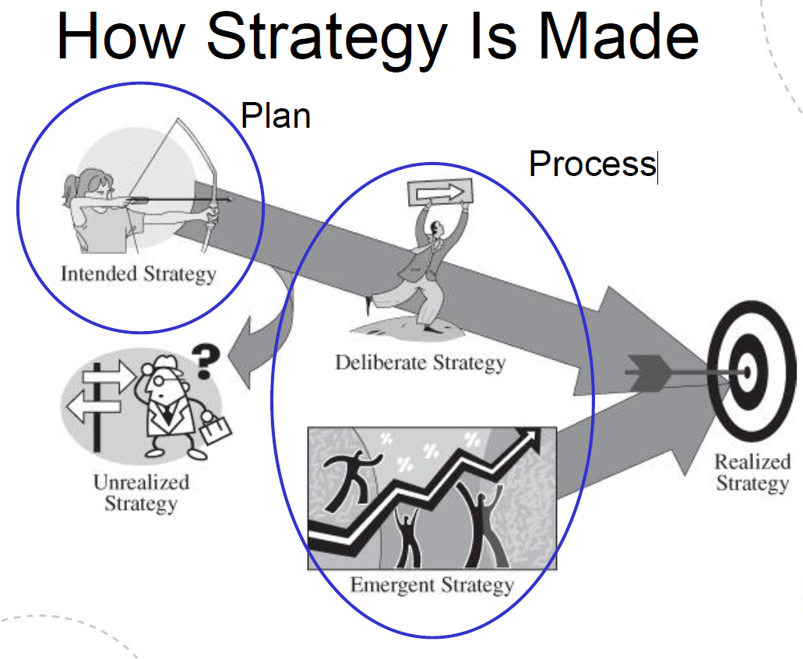

Intended strategy: generally conceived by the top management team, typically through a process of negotiation, bargaining, and compromise among many individuals in the organization.
Deliberate strategy: portion of an organization’s intended strategy that reaches fruition
Unrealized strategy: intended strategy that do not see the light of day
Emergent strategy: uncontrolled or unplanned patterns of action
Realized strategy: actual pattern of decisions made over time

Corporate, Business and Functional Strategies
Book focuses on functional level, specifically on strategy for the operations function. Operations strategy is developed in the context of both corporate and business strategy.
Corporate strategy: identifies the industries and markets in which a firm will compete
Business strategy: determines the market segments in which the business will compete, the partnerships it will leverage in providing solutions to its customers, and the sources of competitive advantage in terms of cost, quality, availability, features/innovativeness, and environmental performance the firm will gain in each segment.
Performance dimensions: derive from the order winners (those that gain more business the better you are) and order qualifiers (“givens” of doing business), translating the customer needs into a set of objectives: cost, quality, availability, feature/innovativeness, environmental performance. These dimensions guide the decisions taken in the various areas of operations.
Dimension | Definition
Cost | Purchase price to the customer  Cost of ownership – lifetime cost of owning, using and maintaining the product or service
Quality | Tangible characteristics: Aesthetics, reliability, durability, safety, serviceability  Intangible characteristics: Competence, courtesy, understanding, and communication. Access and security (see exhibit 1.10 for definitions of tangible/intangible dimensions of quality if needed)
Availability | For purchase: Off-the-shelf or make-to-order  Of new products: rapid cycle or planned evolution  Range of products available: degree of customization
Features/innovativeness | Inherent characteristics of a product or service  Degree of innovation
Environmental performance | Degree to which process that produces and delivers the product or service is environmentally sound  Degree to which the product or service itself is environmentally sound and reusable or recyclable

Market positioning and making trade-offs
Tradeoff model: performance objectives are mutually exclusive. E.g. in order to produce better quality, costly investments are needed.
Tradeoffs exist, but they can be overcome through improvements. See exh.1.11 for trade-offs and performance frontiers. (Comment to 1.11: A worse than B. Same quality for more cost.)
Functional strategy
Functional strategies are the sets of decisions made in each of the functional areas of an organization that determine how it will play in the overall business strategy of the firm. Successful companies drive synergistic decision making among the functions in support of an overall business strategy and leverage cross-functional capabilities to create and/or support business strategy direction.
A business strategy is best supported, or created, when the activities undertaken by the functional areas and/or the capabilities they develop complement one another and work together to achieve the goals of the business. The authors refer to this requirement as cross-functional integration or fit.

Operations strategy
Possible definition of operations strategy (one of many presented in the book): A consistent pattern of decision making in the operations function, which is linked to the business strategy.
Operations strategy implies to make own strategic decision within the context of the business strategy. As operations make up the capabilities of a company they can also drive business strategy. (slides)
The process of developing an operations strategy requires substantial analysis of the market in which the firm operates as well as technical understanding of the operations. Operations strategists must understand the evolution of the industry over time, detect changes in the structure of the industry, and identify competitive challenges and opportunities.
Exh. 1.14: Business and operations strategy performance dimensions
Dimension | Definition | Operations influence
Cost | Purchase price  Cost of ownership | Costs of:  - Materials  - Production  - Delivery  - Distribution  Capital productivity  Inventory turnover  Design for cost  Cost objectives are measured using labor, materials, and capital productivity: inventory turnover, unit cost.
Quality | Tangible characteristics: Aesthetics  - Reliability, durability and safety  - Serviceability  Intangible characteristics:  - Competence, courtesy, understanding and communication  - Access and security | Quality of:  - Materials  - Production  - Delivery  - Distribution  Design for quality  Quality measures include percent defective or rejected, frequency of failure in the field, cost of quality, and mean time between failures.
Availability | For purchase: Off-the-shelf or make-to-order  Of new products: rapid cycle or planned evolution  Variety of range of products available: degree of customization | Availability  - Timeliness of delivery of product or service  - Ability to respond to volume fluctuations  - Timeliness of new product introductions  Delivery performance is measured by percentage of on-time shipments, average delay, expediting response time.  Flexibility is measured by product mix and range, volume, and lead time for new products.
Features/innovativeness | Inherent characteristics of a product or service  Degree of innovation | Process capability  - Capabilities for more featured and innovative products and services  - Process knowledge and ability to extend it  Design and development capabilities  Measures of process capability assess the types of products or services that can be delivered.
Environmental performance | Degree to which process that produces and delivers the product or service is environmentally sound  Degree to which the product or service itself is environmentally sound and reusable or recyclable | Environmental performance  - Managing environmental performance of suppliers or other partners in the supply chain.  - Managing the environmental performance of internal production or service delivery operations  Environmental performance measures include both emission measures (water, air, and solid waste) as well as measures of product reuse and recyclability.

Operations decision categories
Creating a manufacturing strategy essentially entails making a set of decisions regarding the structure and infrastructure of manufacturing.
It is the effective integration and synthesis of structural and infrastructural decisions that create long-term operations excellence. In making decisions in each of these categories, operations managers strive to ensure that the decisions are mutually supportive and consistent with one another. Further, they aim to have the collection of decisions support or facilitate the overall business strategy.
Exh. 1.15: Operations strategy decision categories
Structural decisions | Infrastructural decisions
Vertical integration  Process technology  Capacity  Facilities | Sourcing  Business processes and policies  Product and service generation  Order fulfillment  Service and support  Workforce and organizational design  Supply chain coordination  Information technology  Capabilities development  Lean operations  Quality  Flexibility

Consistency and contribution
The concept of consistency or fit in strategy development and implementation strategic fit. Theories linking context/environment, industry, firm structure and performance. Critical elements to be aligned are
- Internal to the firm, where the implementation of the strategy focuses on obtaining fit between the strategy and the organizational structure
- External to the firm, where the strategy formulation process seeks a fit between the firm’s strategy and the environment in which it operates
- Internal-external fit, where the formulation and implementation of strategy are considered to be interactive elements.
Just as there is a good integration between the business strategy and the functional strategies, there must be consistency and fit among the key elements of an operations strategy as well. The key decisions made in developing an operations strategy must be consistent both internally, in that the decisions made in the various categories (vertical integration, process technology, capacity, facilities, sourcing, business processes and policies, supply chain coordination, information technology, and operations capabilities development) are mutually supportive, and externally, in that the collective set of decisions support the overall business strategy.
Operations strategy requires understanding the implications of the business strategy for performance in cost, quality, availability, features/innovativeness, and environmental performance. It then requires making structural decisions about degree of vertical integration, size, location, and focus on facilities, what type of capacity to add and when, and what types of process technology are needed. It also requires the development and exploitation of capabilities in cross-functional process management, sourcing and supply chain management, quality and flexibility management, and lean operations as well as appropriate investments in information technology. The development of these capabilities and the structural choices must be made in such a way that they are consistent with one another, with the other functional strategies, and with the business strategy of the firm.
The highly iterative process of strategy-making entails understanding what position the firm wants to or can take in the marketplace, summarized in ex.1.16: Integrated strategy-making framework (p.35). The process of strategy-making also entails understanding what capabilities the firm has to offer or can or should develop both within and across the key functional areas of the firm. It further entails integrating or synthesizing the activities and capabilities of the functions to achieve a coherent strategy or fit in support of a desired strategic direction, or in pursuit of a new strategic direction.

