Chapter 2 – Vertical Integration
The vertical integration decision is one of the most critical decisions a company must make in setting business as well as operations strategy. In effect, vertical integration is simply a means of coordinating the stages of the firm’s value chain when bilateral trading is not economic or reliable. Firms making vertical integration decisions ask these questions:
How much of the value chain should my company own, and for the owned activities, how much should be performed in house?
Under what conditions should my company change the amount of the value chain it owns? In what direction – toward my suppliers or toward my customers – should I make those changes?

Defining Vertical Integration
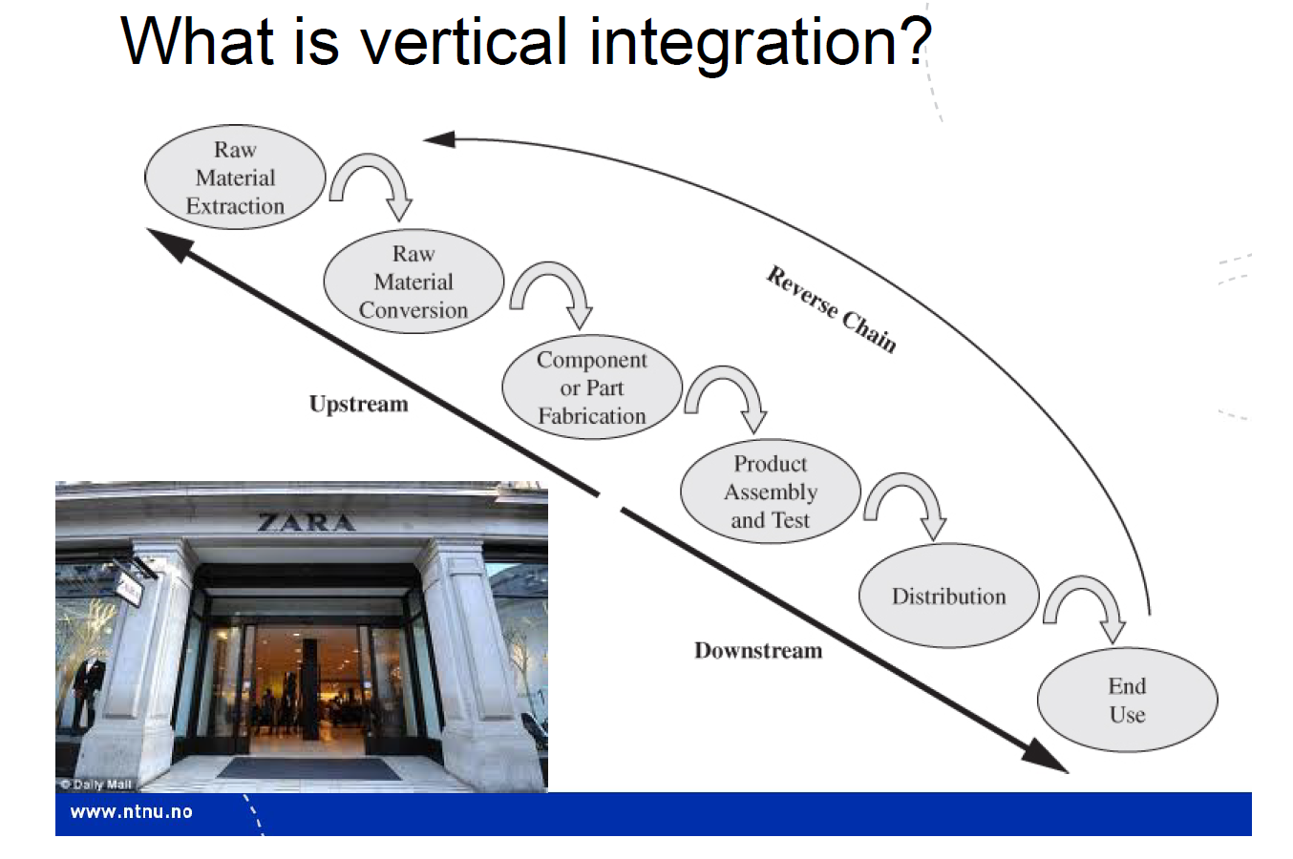
Companies that choose to move upstream and own more of the supply end of their value chain are backward integrating. Those companies choosing to move downstream and own more of the customer end of the value chain are said to be forward integrating. Companies may also decide to vertically disintegrate, shedding upstream or downstream operations by outsourcing them.
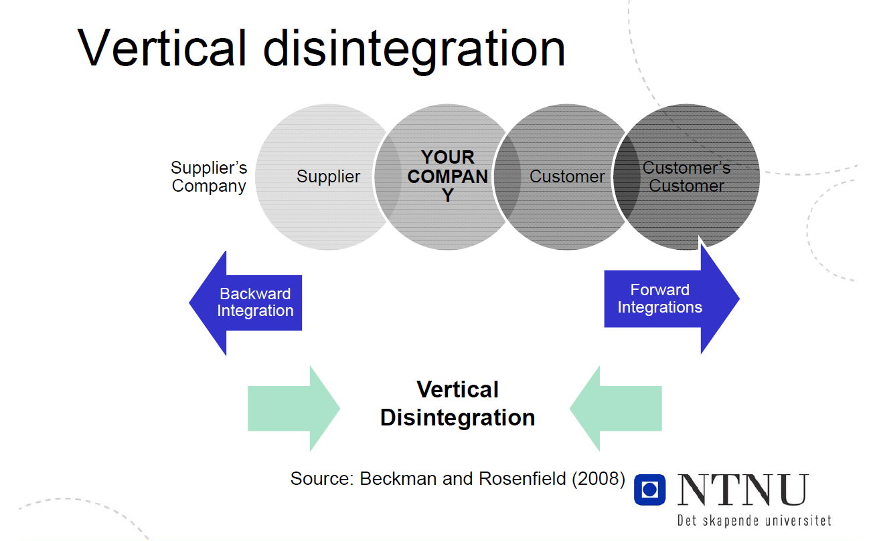
These vertical integration decisions shift the boundaries of the organization, changing what activities the organization will perform internally and the nature of its relationships with the resulting suppliers and customers.
Exhibit 2.2 – Comparison of Upstream and Downstream Activity Characteristics
 | Upstream activities tend to | Downstream activities tend to
Products | Produce a narrower line of more standardized outputs | Produce a broader line of more specialized outputs
Processes | Employ more automated, capital-intensive processes that require longer production runs and have higher break-even points | Employ less automated, more labor-intensive processes that allow for shorter production runs and lower break-even points
Economics | Have higher break-even points resulting in lower responsiveness to market downturns and higher profit variability | Have lower break-even points resulting in higher responsiveness to market downturns and lower profit variability

Some companies choose to make horizontal integration decisions; these companies continue to perform the same set of activities they have always performed, but do so in a different industry or market (see exh.2.4, p.44)

The vertical integration decision
Four factors to be considered in making a vertical integration decision (from summary. Will elaborate on some of the factors):
- Strategic factors link the vertical integration decision to the firm’s choice of core capabilities on which it will compete. From a strategic perspective, firms ideally own only the activities that are core, essential or critical, and may outsource all other activities if possible.

- Market factors address the reliability of the available supplier markets for the activities the firm chooses not to own, and consider the structure and dynamics of the industry in which the firm resides. A firm may choose to own an activity to control its performance, gain market power, or reduce dependence on an outside supplier. A firm may choose to outsource to improve process economics and performance.

- Product and technology factors relate an operations decision to outsource to technology strategy and product architecture. A firm may choose to own a process if the technology underlying that process is new or is integral to the firm’s products, or there is uncertainty associated with the product/process relationship. It may, on the other hand, outsource a process if the underlying technology development is also outsourced and/or the technology is used in a modular product architecture making it easy to separate from the product.

- Economic factors provide tangible data about the cost of a vertical integration decision. A firm may choose to own an activity if it can perform that activity at lower cost, the investment required is reasonable, and the transaction costs associated with procuring the output of the activity from outside are high. A firm may outsource when it cannot achieve these economies.

Market factors
Two classical approaches to organizing:
Markets: apply in vertically disintegrated environments; rely on self-interested exchanges on the part of buyers and suppliers to coordinate the completion of work
Hierarchies: rely on the authority associated with legal ownership to assign work to subsidiary entities and monitor its completion.
In reality, these represent two extremes on a spectrum of options from which firms may choose. Four major market factors to be considered in choosing where on the spectrum to position a firm:
Market reliability: refers to the ability of a supply base to perform along cost, quality, availability, features/innovativeness, and environmental dimensions.
Ensuring performance through competition or Ensuring performance through control
Economies of scale: achieved when the unit cost of producing a good or delivering a service decreases as the volume of that good or service increases.
Obtaining scale from multiple sources (supplier able to produce or deliver in greater volumes than the customer) vs. obtaining scale by reducing the effects of variability and uncertainty
Market power: number of players, relative sizes and profitability.
Asset specificity and dependency risk: dependency risk arises whenever at least one party in a transaction adapts its process in some way to accommodate the demands of the other party.
Asset specificity refers to that one or both parties make investments in assets- people, equipment or physical facilities – at the behest of the other party and are unlikely to be able to redeploy those assets for use in another application with another party. High asset specificity creates dependence/interdependence, reduces the number of manufacturers or suppliers who can enter into that specific transaction, thus concentrating market power.
Six types of asset specificity:
Site specificity – locate fixed assets in close proximity to minimize transport costs and maximize assets
Dedicated assets- discrete investments in general-purpose plant and equipment that are made at the behest of a particular customer and in essence represent capacity that is dedicated to that customer
Physical asset specificity- one or both parties to a transaction invest in equipment or tooling (specialized dies) specific to that transaction and with a low value in alternative uses
Human capital specificity- employees develop skills that are specific to a particular buyer or customer relationship
Brand name capital – investments in brand building
Temporal specificity – investments made that link the two parties at a particular point in time
Exhibit 2.7: Vertical integration options based on transaction frequency and asset specificity
 | High asset specificity | Low asset specificity
High transaction frequency | Vertical integration | Standardized transactions not necessarily requiring contracts
Low transaction frequency | Detailed, probably unique contracts | Detailed, standardized contracts

Product, Service and Technology factors
Intellectual property (IP): particularly that surrounding core products, services and technologies. Outsourcing risk of giving IP to competitors.
Technology differentiation (TD)
Achieve TD through vertical integration, to rapidly accommodate technological change. Or does vertical integration lock-in the firm, making it harder for the firm to adopt new technologies quickly when needed?
Exh. 2.8: Technology Access Vertical Integration Decisions
 | Capabilities exist outside | Capabilities must be developed
Autonomous or stand-alone technology | Do not vertically integrate | Ally with technology developer or bring technology in house
Systemic or integrated technology | Ally with technology provider with caution | Vertically integrate, bringing technology development in house

Modular or integral product architecture
The more integral a part is to a product or service design, the more likely the organization will be to own the capability for producing that part.
Exh.2.9: Part access vertical integration decisions
 | Dependent for Capacity only | Dependent for Knowledge and Capacity
Autonomous, stand-alone or modular item | Best outsourcing opportunity | A potential outsourcing trap- consider vertical integration
Systemic or integrated item | Can live with outsourcing | Worst outsourcing situation – should vertically integrate if possible

Economic factors
An economic analysis of a vertical integration decision involves understanding the costs of producing the product or delivering the service both internally and at the supplier site.
Relevant factors: Investment costs, Design, production and delivery costs, Transaction costs

A spectrum of options
Exh. 2.11: Comparison of Costs for Internal ownership versus outsourcing

Type of cost | Cost of owning an activity | Cost of outsourcing an activity
Design, production, or service delivery costs | Materials  Labor (Direct)  Overhead  Production  Procurement  Engineering | Purchase cost includes:  Labor (Direct)  Materials  Overhead  Vendor profit
Transportation and logistics costs | Cost of moving output from site of creation to site of use | Cost of moving output from vendor’s location to buyer’s site of use
Investment costs | Capital (equipment and space)  People resources (hiring, training)  System development  Inventory
Transaction costs |  | Contracting costs, including purchasing, sales, marketing, taxes, legal  Coordination costs including engineering, forecasting, production scheduling

Summary of the factors for and against vertical integration
Exh. 2.12: Factors for and against vertical integration
 | Vertically integrate to | Vertically disintegrate to
Strategic factors | Develop and retain core and essential capabilities | Access a core or essential capability externally while working on its development internally
Market factors | Control cost, quality, availability, features/innovativeness and environmental performance in unreliable markets  Shift power relationships in the industry  Reduce dependency (due to asset specificity) on suppliers | Leverage competition among suppliers to access best-in-class performance  Aggregate demand at suppliers thus generating economies of scale and improved responsiveness to variability in demand
Product and technology factors | Control integral or critical technologies  Integrate design and production or service delivery under uncertain conditions | Access current technologies not available internally  Obtain leverage available from modular product architectures
Economic factors | Minimize transportation and logistics costs  Minimize transaction (contracting and coordination) costs | Access lower production or service delivery costs  Minimize investment costs
Making a vertical integration decision requires carefully assessing the pros and cons associated with each of these factors.

Making a vertical integration decision
Followings steps recommended in making a vertical integration or disintegration decision:
- Apply the core capabilities screen identifying which activities should be retained in house and which are potential candidates for outsourcing
- Assess the industry context and dynamics, identifying weaknesses and opportunities that might be exploited through a change in vertical integration
- Identify alternative value chain structures, realistically naming practical options for acquiring or shedding a capability.
- Assess alternatives and choose one based on the cost, quality, availability, features/innovativeness, and environmental performance of each alternative as well as its strategic contribution
- Implement the chosen alternative, remaining aware of the cost targets to be achieved and the associated risks.

Possible outcomes of the vertical integration decision
Even though incremental moves to outsource individual activities can be justified on the basis on cost efficiency, in the long run, unless a company focuses on developing and maintaining its own core capabilities, it can lose the ability to innovate and perform its own activities at best-in-class levels.

