Contents
Business Process-Focused Strategies and Org. Design 3
Definitions: 3
Key Questions 4
Business Process Management 4
Emergence of the Process-Based View 4
Process and Value-Stream Mapping 5
Operations-Related Business Processes 6
Product and Service Generation 6

Business Process-Focused Strategies and Org. Design

Definitions:

Business process:
- Related structured activities that produce a specific product or service.
- All operations are transformations processes that transforms input into output with a higher value for the customer
Lead time is the latency (delay) between the initiation and execution of a process. For example, the lead time between the placement of an order and delivery of a new car from a manufacturer may be anywhere from 2 weeks to 6 months.
Order fulfillment is in the most general sense the complete process from point of sales inquiry to delivery of a product to the customer.
The first research towards defining order fulfillment strategies was published by Mather (1988) and his discussion of the P:D ratio, whereby P is defined as the production lead-time, i.e. how long it takes to manufacture a product, and D is the demand lead-time, i.e. how long customers are willing to wait for the order to be completed. Based on comparing P and D, a firm has several basic strategic order fulfillment options:^{[1]}
- Engineer-to-Order (ETO) - (D>>P) Here, the product is designed and built to customer specifications; this approach is most common for large construction projects and one-off products, such as Formula 1 cars
- Build-to-Order (BTO); syn: Make-to-Order (MTO) - (D>P) Here, the product is based on a standard design, but component production and manufacture of the final product is linked to the order placed by the final customer's specifications; this strategy is typical for high-end motor vehicles and aircraft
- Assemble-to-Order (ATO) - (D<P) Here, the product is built to customer specifications from a stock of existing components. This assumes a modular product architecture that allows for the final product to be configured in this way; a typical example for this approach is Dell's approach to customizing its computers.
- Make-to-Stock (MTS); syn: Build-to-Forecast (BTF) - (D=0) Here, the product is built against a sales forecast, and sold to the customer from finished goods stock; this approach is common in the grocery and retail sectors.
- Digital Copy (DC) - (D=0, P=0) Where products are digital assets and inventory is maintained with a single digital master. Copies are created on-demand, downloaded and saved on customers' storage devices.

What is a Metric?
A metric is nothing more than a standard measure to assess your performance in a particular area. Metrics are at the heart of a good, customer-focused process management system and any program directed at continuous improvement. The focus on customers and performance standards show up in the form of metrics that assess your ability to meet your customers' needs and business objectives.
Secret 1 - Measure the right things

Key Questions
- On which business processes should the company focus to achieve success in the market?
- How should the company align its resources and capabilities to optimize performance of the business process?
In this chapter, we explore the concept of process management as a means of achieving competitive advantage and then describe three primary business processes important to many organizations:
- Product or service generation
- Order fulfillment
- Service and support
For each process, we discuss the importance of integrating mgt, process, org and IT to achieve optimal process performance.

Business Process Management
Research suggests that capability development (achieving process excellence) is critical to achieve competitive advantage ( ikke bare positioning som er avgjørende)

Emergence of the Process-Based View
Business Process Reengineering (BPR) suggests that a company should not only focus on continuous improvement, but sometimes radically redesign and reorganize to reduce cost and increase process performance.
Seven principles underlie the BPR approach:
- Organize around outcomes, not tasks
- Prioritize all of the processes in the org. in order of redesign urgency
- Integrate information processing with the work that produces the information
- Treat geographically dispersed resources as though they were centralized
- Link parallel activities in the workflow instead of just integrating their outputs
- Move decision making to where the work is performed, and build control into the process
- Capture information once and at the source
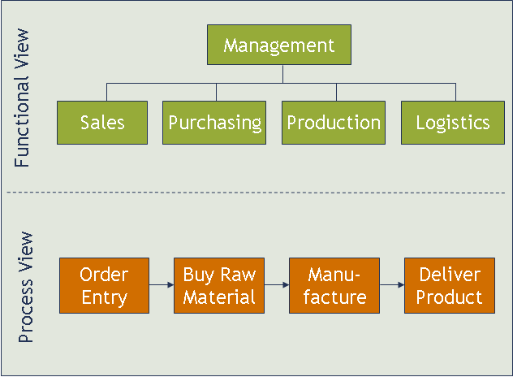

This approach forced companies to take an integrated view of their processes, examining in detail how information flows were managed and then simultaneously design the process flow, org structure and information systems to support the most efficient information flow possible.
Process view vs. functional view: examines the business in terms of processes rather than functions. The business process view (BPV) focuses on what customer wants and forces the org to focus on value adding activities (seen from a cross-functional view). F.eks: hvis en kunde ønsker rask leveranse av en ordre kartlegg hvordan order fulfillment prosessen fungerer, identifiser flaskehalser, hvor informasjon blir usynlig og/eller hvorfor informasjonsflyten går sakte integrer funksjonelle enheter (sales, production, logistics) vha. IT (i.e. ERP – enterprice resource planning), org struktur og prosesser for å redusere leveransetid. Mao. Process view fokuserer først på customer needs, deretter på hvordan dette dette oppnås gjennom verdiskapende aktiviteter og prosesser.

Process and Value-Stream Mapping
There are two widely used tools that support process analysis:
- Process mapping: generally used in applications of business process reengineering and Six Sigma
- Value-stream mapping: used to map physical flows, particularly in applications of lean operations

Process Mapping
Hierarchical method to describe how a transaction is processed. Visual representation of a workflow that shows the stream of activities involved in converting a set of inputs to a desired set of outputs.

Se side 258: er et kurrant eksempel der.
Essensen er at man benytter process mapping som et verktøy for å kartlegge processen fra ordre mottakelse (inquiry) til leveranse. Ved å visualisere prosessen kan man enklere avdekke svakheter og kilder til ineffektivitet og leadtime. Man starter kartleggingen ved først å lage et AS-IS process map finne leaks/svakheter foreslå et TO-BE process map hvor justeringer/kalibreringer er gjort for å optimere prosessen. Resultat av analyse: Investere i IT systemer som vil automatisere interne steg i processen, øke informasjons synlighet og flyt-tempo.

Value stream mapping
Used to visualize and understand the flow of material and information as a product or service makes its way through the value stream.
Summary:
VSM og BPM benyttes for å illustrere både foretningsmessige og fysiske prosesser og fungerer som et verktøy for å skissere effektivisering/optimering av kryssfunksjonelle prosesser.

Operations-Related Business Processes

Product and Service Generation
Se side 262 for figurer og illustrasjoner.
During product generation a company seeds out the best prospects through a product or service development funnel (en trakt som ser på strategic fit, tech. feasibility, market acceptance, economic returns etc ut av trakten kommer nye produkter som integreres i product portfolio)
New product or Service Development Process
Planning Concept Development System-level Design Detailed Design Testing and Refinement Production, Delivery, Ramp-up
To reduce time to market and increase ability to respond to late changes companies can overlap phases of production generation (concurrent development). The process can alternatively be iterated fast (loops).
Product generation and derived cross-functional processes requires an integrated management system, including top mgt guidance, a defined process, supportive cross-functional org structures and integrative IT. One of the key drivers for managing such integrated system is a set of metrics that relate the performance of the process to customer needs and desired business outcomes.

Product and service generation matrics
It is critical to measure the right variables to motivate the product generation team to behave according to objectives. TTM (time to market) and TTV (time to volume) is commonly applied measures. TTV forces the development org. to concern itself with how the product will be manufactured or how the service will be delivered and to make ramp to volume as smooth as possible.
BET (break even time) measures the amount of time from concept development until the product or service breaks even, paying back the investment in its development.

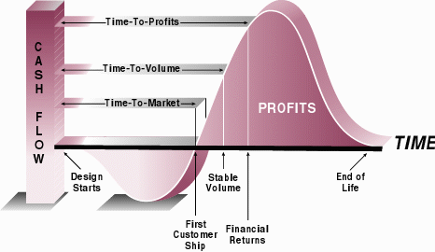

Organizing for product and service generation
Product generation is inherently an information processing exercise. information from one step/phase/person/team is used in another step/part. therefore it is needed to iterate back and forth between stages to progress. The organizational design that best supports a new product generation process optimizes information flow among players. Often those information flows are dictated by the architecture and design of the product. F.eks Flymotor består av 8 systemer: 6 modular og integrative. Hvert system har 5 til 10 componenter, totalt 54 componenter. Design grenseflaten (interface) kan illustreres i et design structure matrix:

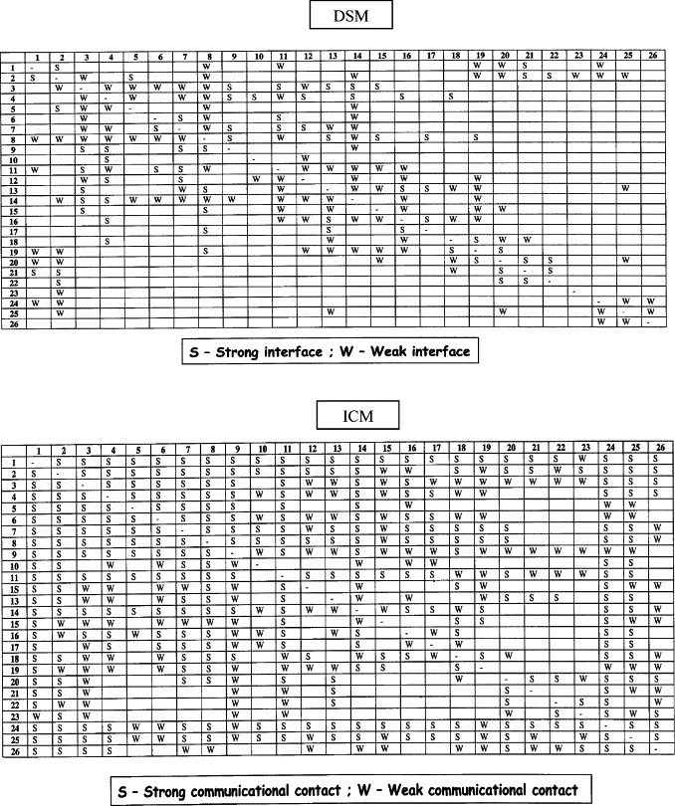
Denne matrisen er ikke fra boka og er litt annerledes bygd opp. I boka har de
- en matrise for design interfaces som beskriver graden (strong/weak) av design interface (tolker det som graden av «interface» mellom komponenter i flymotoren hvor integrerte komponentene er med hverandre)
- en matrise som viser hvordan kommunikasjonen mellom teamene (60 team) burde være for å sikre informasjonsflyt mellom teamene slik at komponentene er integrerbare med hverandre. denne matrisen skal vise kommunikasjon mellom teamene

Bottom line: Organisasjonsstrukturen burde konfigureres slik at informasjonsflyten som kreves av produkt arkitekturen. Hvis det er en mismatch org. Redesign
Heavy weight project manager: High degree of control over their projects and resources assigned to them from the functions. Light weight proman: motsatt, høy autonomi
Core team: Team with representatives from each functional area that is charged with magknig key deicisions about the product.
There is a range of org designs that can be used to support the optimal information flow.

IT supporting Product and service generation
Product data management (PDM) systems, sometimes known as engineering data management systems, manage engineering data, perform version control and configuration management, and facilitate workflow through the product generation process. They store all of the data related to a product and to the processes that will be used to design, manufacture, deliver, and support the product.
Today PDM is integrated into ERP. Benefit product generation tasks integrated with supply chain

Order Fulfillment and Processing
The order fulfillment process starts with an interaction with the customer that results in a capturing an order and ends when that customer’s order has been fulfilled. Capture manage fulfill follow up
Se side 272 for figure.
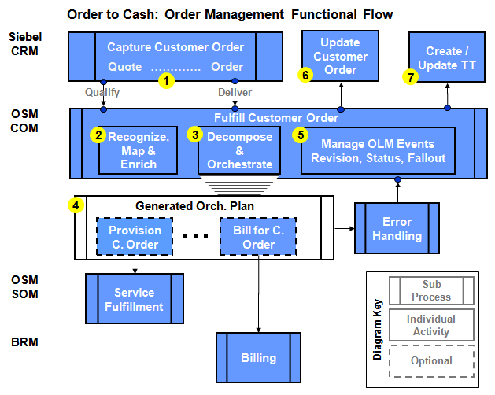

Order Fulfillment Process Metrics
Two general measures of order fulfillment:
Omg. Les I boka page 273. WARNING: BORDERLINE SVADA

Organizing for Order Fulfillment
To create an integrated order fulfillment process that performs well against the customer focus, the steps of the process must be linked and intermediate queuing between them limited.
Very often the easiest way to achieve integration of the order fulfillment process is through the development and implementation of IT that allows information to flow readily among the functions and in many cases makes decisions without human intervention.

Information Technology Supporting Order Fulfillment
Selskaper må ha et IT system som støtter informasjonsflyt mellom enheter.

Service and Support
Often viewed as peripheral, not contributing to competitiveness.
Blablabla. Mye svada les om dere er keen.

Service and support Process metrics
A company should use metrics to assess the service and support processes. Speed and quality of service most are the most important metrics/measures.

Organizing for Service and Support
Requires integration among functional areas. As for order fulfillment, it is rare to find cross-functional teams dedicated to service and support, as it is an ongoing set of transactions with the customer that needs to be managed. Instead, task forces may be deployed to set metrics for the process and to study it to find ways in which it might be improved.
REMINDER:
What is a Metric?
A metric is nothing more than a standard measure to assess your performance in a particular area. Metrics are at the heart of a good, customer-focused process management system and any program directed at continuous improvement. The focus on customers and performance standards show up in the form of metrics that assess your ability to meet your customers' needs and business objectives.

IT supporting service and support
One of the best ways to integrate the service and support functions.
CRM (customer relationship management) systems er bankers. software som fasiliterer kunderelasjoner. oversikt over prospekts, status på orders, database med tonn av info.

Choosing a Business Process Focus
Hva man fokuserer på er avhengig av hvilke performance measures man ønsker å optimere og bruke som kilde til konkurransefortrinn. A company conpeting on innovativeness and features might depend on the superiority of its product or service generation process. A company competing on availability might invest in developing its order fulfillment capabilities. A company competing on quality might want to ensure the best end-to-end customer experience with strong service and support processes.
Whatever processes the company chooses, it will have to invest in developing the metrics, process, org. structure, and IT to develop the process to the level at which it can provide competitive advantage.

Organizational Design of Operations
Organizational design requires first understanding the company’s strategic direction and then integrating the elements of an organizational design to support that strategy:
- Organizational structure: who report to whom; where decision-making power is located
- Decision-making processes: how information flows around the organization and how decisions get LAID eller made
- Human resources: what skill sets are needed in which positions; how they are hired, trained, fired, blowed
- Rewards: how people are measured, motivated, and rewarded both intrinsically and extrinsically. Measure: Penis size, Motivation: BJ’s, handjobs

Ikke ferdig

